Lab Report

By: Jahmil Ally (501045419)

# Observations and Analysis

## Q1:

Data Flow Graph:

|  |  |
| --- | --- |
| Node | Lines |
| 1 | 1,2,3,4 |
| 2 | 5 |
| 3 | 6, 7 |
| 4 | 8 |
| 5 | 9 |
| 6 | 10 |
| 7 | 11 |
| 8 | 12, 13 |

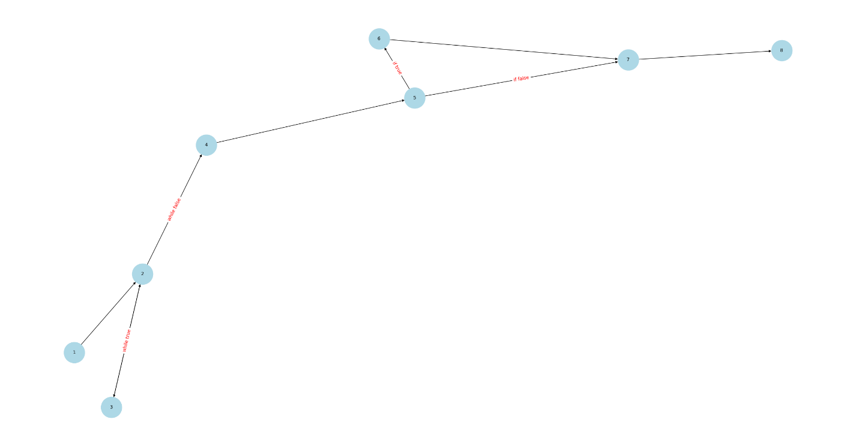

Output:

## Q2:

Data Flow Graph:

|  |  |
| --- | --- |
| Node | Lines |
| 1 | 1 |
| 2 | 2 |
| 3 | 3 |
| 4 | 4, 5, 6 |
| 5 | 7 |
| 6 | 8 |
| 7 | 9 |
| 8 | 10, 11 |
| 9 | 12, 13 |

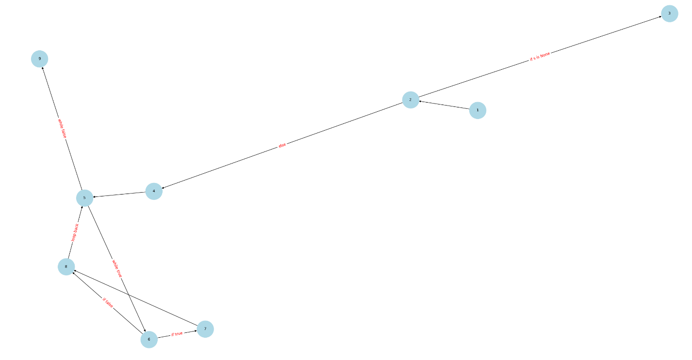

Output:

## Q3:

1. Control flow and data flow coverage graph

|  |  |
| --- | --- |
| Node | Lines |
| 1 | 1 |
| 2 | 2, 3,4 |
| 3 | 5 |
| 4 | 6 |
| 5 | 7, 8, 9 |
| 6 | 10 |
| 7 | 11 |
| 8 | 12 to 19 |

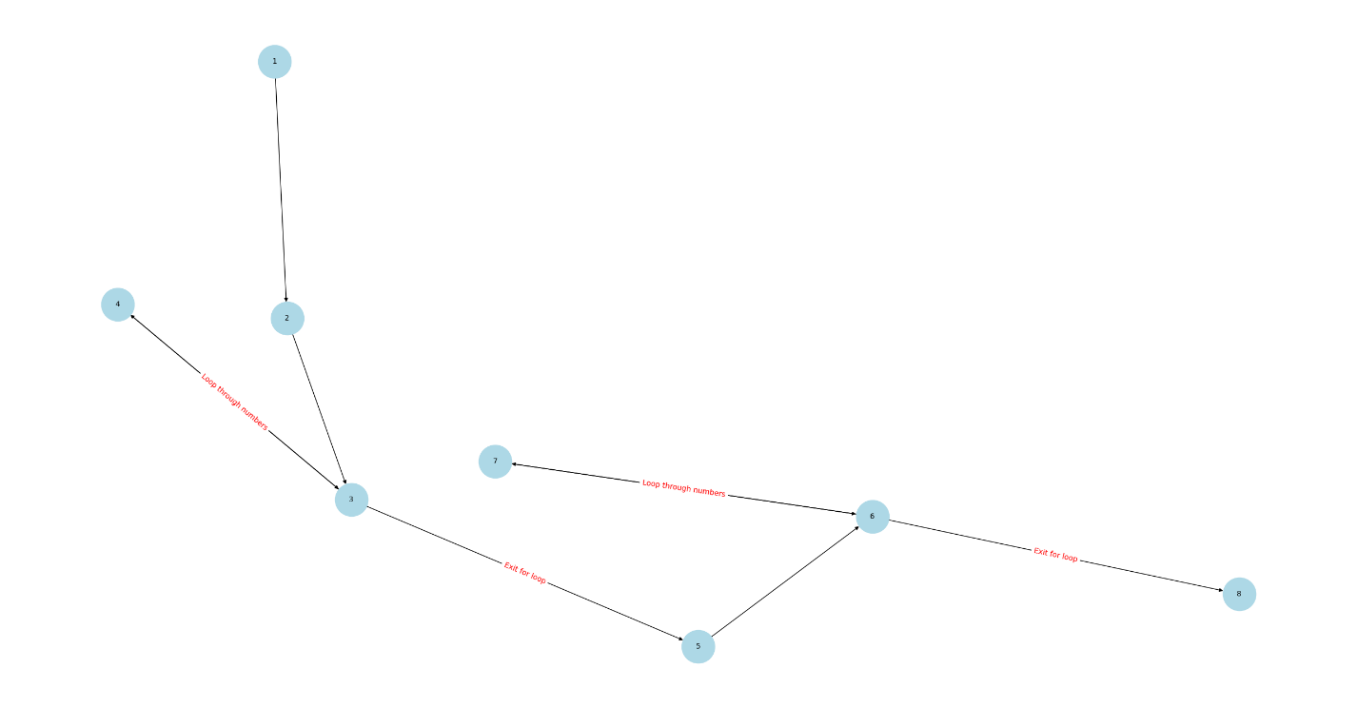

1. DU Pairs (Node Pairs) for Each Variable

DU pairs are pairs of nodes where a variable is defined (D) and used (U).

* + length:
    - Defined at node 2
    - Used at nodes 3, 5, 6, 8
  + sum_values:
    - Defined at node 2
    - Used at nodes 4, 5
  + numbers_sorted:
    - Defined at node 5
    - Used at node 5
  + median:
    - Defined at node 5
    - Used at node 8
  + mean:
    - Defined at node 5
    - Used at nodes 7, 8
  + varsum:
    - Defined at node 5
    - Used at nodes 7, 8
  + variance:
    - Defined at node 8
    - Used at node 8
  + standard_deviation:
    - Defined at node 8
    - Used at node 8

1. DU Paths for Each DU Pair for Each Variable

DU paths are paths from a definition to a use of a variable.

* + length:
    - (2, 3): length is defined at node 2 and used at node 3
    - (2, 5): length is defined at node 2 and used at node 5
    - (2, 6): length is defined at node 2 and used at node 6
    - (2, 8): length is defined at node 2 and used at node 8
  + sum_values:
    - (2, 4): sum_values is defined at node 2 and used at node 4
    - (2, 5): sum_values is defined at node 2 and used at node 5
  + numbers_sorted:
    - (5, 5): numbers_sorted is defined and used at node 5
  + median:
    - (5, 8): median is defined at node 5 and used at node 8
  + mean:
    - (5, 7): mean is defined at node 5 and used at node 7
    - (5, 8): mean is defined at node 5 and used at node 8
  + varsum:
    - (5, 7): varsum is defined at node 5 and used at node 7
    - (5, 8): varsum is defined at node 5 and used at node 8
  + variance:
    - (8, 8): variance is defined and used at node 8
  + standard_deviation:
    - (8, 8): standard_deviation is defined and used at node 8

1. Test cases to cover du paths

1. Can’t run all test cases to cover du paths
   * IndexError: This occurs because the program tries to access an element in an empty list. Specifically, numbers_sorted[length // 2] tries to access an element at index 0, which does not exist in an empty list.
   * ZeroDivisionError: This occurs because the program tries to divide by zero. Specifically, mean = sum_values / length and variance = varsum / (length - 1) both involve division by zero when length is 0 or 1.

## Q4:

1. Control flow and data flow coverage graph

|  |  |
| --- | --- |
| Node | Lines |
| 1 | 1, 2, 3, 4 |
| 2 | 5 to 12 |
| 3 | 13 |
| 4 | 14, 15 |
| 5 | 16 |
| 6 | 17 |
| 7 | 18 to 22 |
| 8 | 23 |
| 9 | 24, to 27 |
| 10 | 28 |
| 11 | 29 |
| 12 | 30 |

1. Test Case: n = 1

When n = 1, the initial value of num_primes is 1. The while loop condition num_primes < n will be 1 < 1, which is false. Therefore, the while loop body will not be executed, and the control will directly move to the for loop that prints the primes

1. Test Paths for Edge Coverage but Not Prime Path Coverage
   * Input: n = 1
     + Path 1: 1 -> 2 -> 3 -> 10 -> 11 -> 10 -> 12
     + This path covers the edges from the start to the initialization, checks the while loop condition (which is false), and then moves to the for loop to print the primes.
   * Input: n = 2
     + Path 2: 1 -> 2 -> 3 -> 4 -> 5 -> 6 -> 5 -> 8 -> 9 -> 3 -> 10 -> 11 -> 10 -> 12
     + This path covers the edges from the start to the initialization, checks the while loop condition (which is true), executes the while loop body, checks the for loop condition, finds a prime, and then moves to the for loop to print the primes.
2. Unit Tests

# Appendix:

## Q1:

## Q2:

## Q3:

## Q4:

